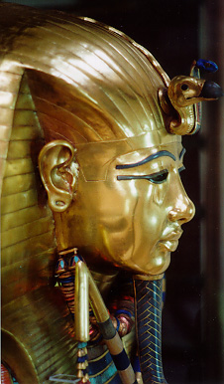
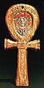
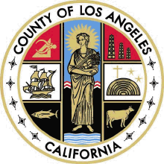

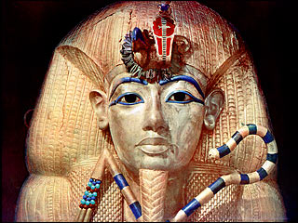
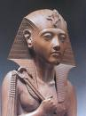
o
~Multicultural ~

ALIGNED TO THE STATE

HISTORY/SOCIAL SC.
STANDARDS &

OPEN COURT

READING THEMES

“The QUEENS OF THE NILE, NOW performance at the Official King Tutankhamen U.S. Welcome and Opening Day Cultural Program was beautifully produced and enthusiastically received. Egypt, the Glorious 18th Dynasty is an excellent Exhibit companion program that I recommend to schools nationwide.
~ Supervisor Yvonne Burke
Los Angeles County Board of Supervisors

~Storytelling ~

~Role Playing ~
$300./Show
Multiple Show Discount
Earlybird
Rates

Available

Book Today

EGYPT

THE GLORIOUS
18TH DYNASTY Long before baseball caps, basketball jerseys and low rider jeans, what we wore spoke volumes about who we are. In a historical exploration of the artistry and symbolism of ancient Egyptian regalia, Queens Historical Society presents
EGYPT: THE GLORIOUS
18TH DYNASTY.
In this interactive storytelling session, which features a magnificent collection of crowns and gowns, volunteer students are transformed from 21st Century youth into three of Egypt’s most renown and well dressed rulers.
~QUEEN HATSHEPSUT ~
~QUEEN TIYE ~
~KING TUTANKHAMEN ~
In under an hour, students learn about Kings and Queens (leaders), experience another culture and are transported to another time, to another continent, where caps were crowns, robes were regal and handmade sandals were the hottest shoe on the market.
Recommended for Grades 1 – 6

”The amount of history taught in a highly imaginative and artistic way was unbelievable.” – Mrs. Jeff – Los Angeles USD

“I enjoyed the program. It gave me a chance to think as though I was a part of history – Rose Fleming – 7th Grade
www.queenshistoricalsociety.com / 562 570-4079
Featuring
QUEEN
HATSHEPSUT

